- What are the recent updates in Instant Redemption Facility post SEBI Circular?
In the light of recent SEBI Circular dated 8th May 2017:
- The limit for instant withdrawal per day/per investor/per scheme has been revised to the lower of Rs.50,000 or 90% of available balance
- Instant redemption facility in ICICI Prudential Savings Fund will be withdrawn shortly, and will be made available in a scheme as permitted under the regulation.
- How will I be able to redeem my money invested in ICICI Prudential Savings Fund?
Till the time, changes are implemented for scheme change you’ll be able to utilize instant redemption facility in the scheme.Post the change youcan continue to make normal withdrawals that will be credited as per normal business cycle.
- Will the instant redemption facility be made in any other fund?
Yes.Instant redemption facility will soon be made available in ICICI Prudential Liquid Fund-Growth option.
- Instant redemption facility will be available to?
Resident individuals Investors.
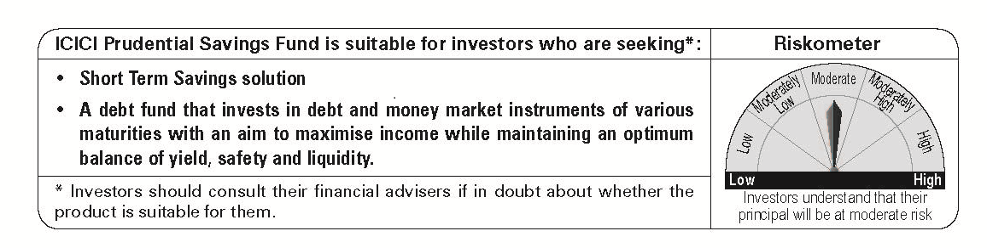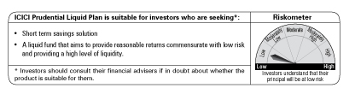
Mutual Fund investments are subject to market risks, read all scheme related documents carefully

